How to Install Kubernetes (k8s) 1.7 on CentOS 7 / RHEL 7

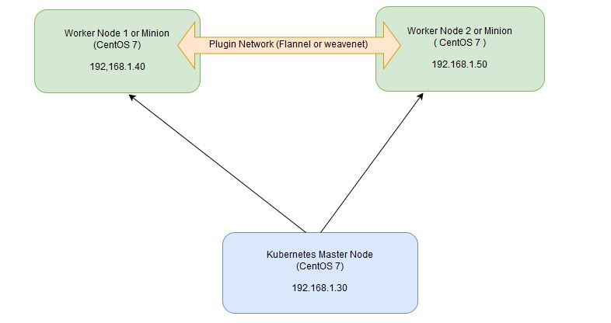

Min Virtual machine requirement
CPU 2
RAM 1.5 GB
Disk 10 GB

No of Node – 3 , 1 for Kubernetes Master and 2 for the Nodes.

On the Master Node following components will be installed
- API Server – It provides kubernetes API using Jason / Yaml over http, states of API objects are stored in etcd
- Scheduler – It is a program on master node which performs the scheduling tasks like launching containers in worker nodes based on resource availability
- Controller Manager – Main Job of Controller manager is to monitor replication controllers and create pods to maintain desired state.
- etcd – It is a Key value pair data base. It stores configuration data of cluster and cluster state.
- Kubectl utility – It is a command line utility which connects to API Server on port 6443. It is used by administrators to create pods, services etc.

On Worker Nodes following components will be installed
- Kubelet – It is an agent which runs on every worker node, it connects to docker and takes care of creating, starting, deleting containers.
- Kube-Proxy – It routes the traffic to appropriate containers based on ip address and port number of the incoming request. In other words we can say it is used for port translation.
- Pod – Pod can be defined as a multi-tier or group of containers that are deployed on a single worker node or docker host.

Step 1: Disable SELinux & setup firewall rules

BELOW COMMANDS TO BE EXECUTED ON ALL THE 3 NODES (1 MASTER AND 2 CLIENT NODES)
Login to your kubernetes master node and set the hostname and disable selinux using following commands
exec bash
setenforce 0
sed -i --follow-symlinks 's/SELINUX=enforcing/SELINUX=disabled/g' /etc/sysconfig/selinux
Set the following firewall rules.
firewall-cmd --permanent --add-port=6443/tcp
firewall-cmd --permanent --add-port=2379-2380/tcp
firewall-cmd --permanent --add-port=10250/tcp
firewall-cmd --permanent --add-port=10251/tcp
firewall-cmd --permanent --add-port=10252/tcp
firewall-cmd --permanent --add-port=10255/tcp
firewall-cmd --reload
modprobe br_netfilter
[root@k8s-master ~]# echo '1' > /proc/sys/net/bridge/bridge-nf-call-iptables

Note: In case you don’t have your own dns server then update /etc/hosts file on master and worker nodes
192.168.1.101 k8s-master
192.168.1.102 k8s-node1
192.168.1.103 k8s-node2

Note: -- In this scenario, we have the private network as “192.168.1.0/24” for this lab setup.
Please check the network in which you are working and accordingly, change the “4th Octect”.
Also, switch off the swap on all the 3 virtual machines as a requirement for Kubernetes Cluster
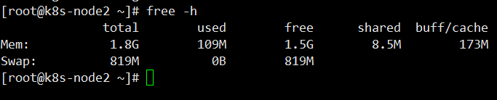

swapoff -a

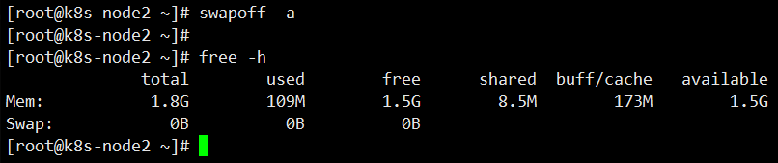

Let’s make this config permanent, so that for the next reboot of the VM, the swap would be still off.
For that we would need to edit the “/etc/fstab” file
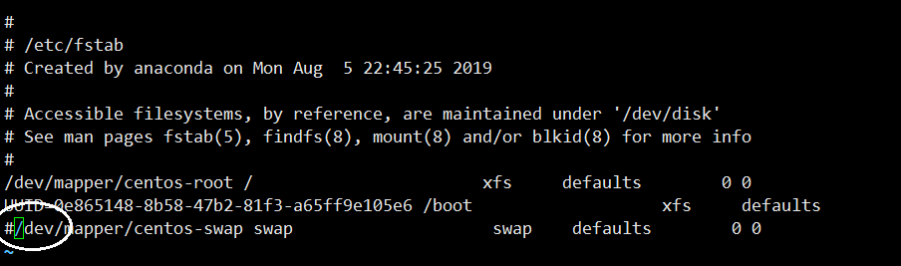
And either “delete” the line that say swap or comment the line with “#” in the beginning of the line.
And Save and quit “:wq”

Step 2: Configure Kubernetes Repository

BELOW COMMANDS TO BE EXECUTED ON ALL THE 3 NODES (1 MASTER AND 2 CLIENT NODES)
Kubernetes packages are not available in the default CentOS 7 & RHEL 7 repositories, Use below command to configure its package repositories.
[root@k8s-master ~]# vi /etc/yum.repos.d/kubernetes.repo
[kubernetes]
name=Kubernetes
baseurl=https://packages.cloud.google.com/yum/repos/kubernetes-el7-x86_64
enabled=1
gpgcheck=1
repo_gpgcheck=1
gpgkey=https://packages.cloud.google.com/yum/doc/yum-key.gpg https://packages.cloud.google.com/yum/doc/rpm-package-key.gpg
[root@k8s-master ~]#

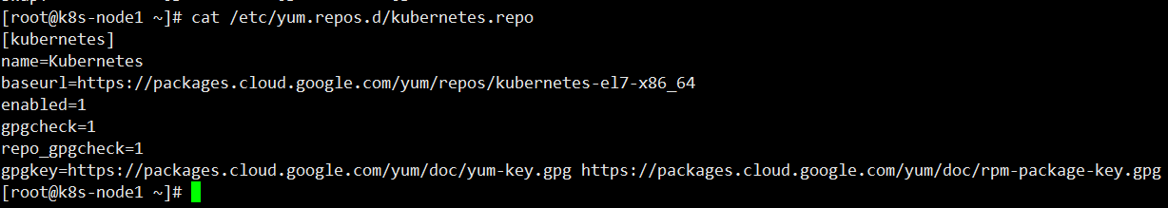
Make sure the alignment and space are exactly the same as the above screen shot, if not the kubeadm packages would not get installed, as the repo may not be recognized.

Step 3: Install Kubeadm and Docker

BELOW COMMANDS TO BE EXECUTED ON ALL THE 3 NODES (1 MASTER AND 2 CLIENT NODES)

Once the package repositories are configured, run the beneath command to install kubeadm and docker packages.

Install Docker CE
Install the latest version of Docker-ce from the docker repository.
Install the package dependencies for docker-ce.

[root@k8s-master ~]# yum install -y yum-utils device-mapper-persistent-data lvm2
Add the docker repository to the system and install docker-ce using the yum command.
[root@k8s-master ~]# yum-config-manager --add-repo https://download.docker.com/linux/centos/docker-ce.repo
[root@k8s-master ~]# yum install kubeadm docker-ce -y
Start and enable docker service
[root@k8s-master ~]# systemctl restart docker && systemctl enable docker

Step 4: Initialize Kubernetes Master with ‘kubeadm init’

BELOW COMMANDS TO BE EXECUTED ONLY ON MASTER NODE

Start and enable kubectl service
[root@k8s-master ~]# systemctl restart kubelet && systemctl enable kubelet

Run the beneath command to initialize and setup kubernetes master.
[root@kube-master ~]# kubeadm init
Output of above command would be something like below
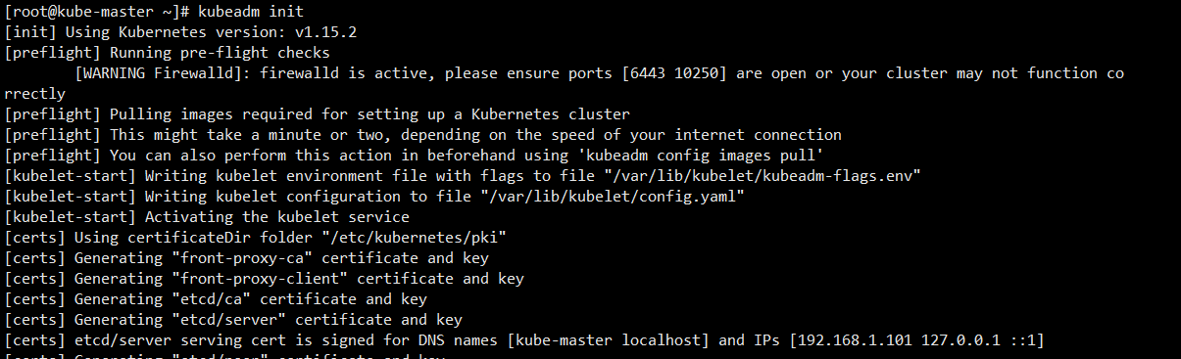

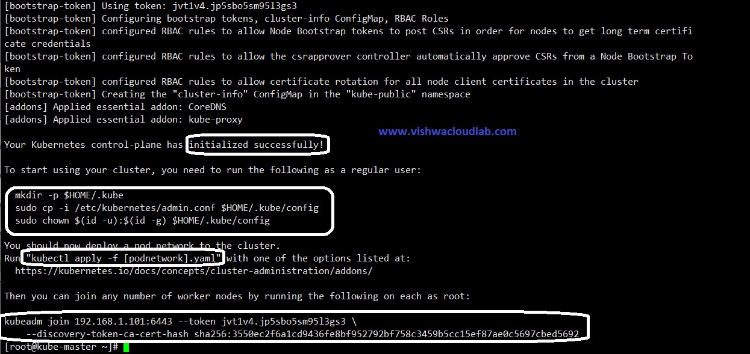
As we can see in the output that kubernetes master has been initialized successfully. Execute the beneath commands to use the cluster as root user.
[root@kube-master ~]# mkdir -p $HOME/.kube
[root@kube-master ~]# cp -i /etc/kubernetes/admin.conf $HOME/.kube/config
[root@kube-master ~]# chown $(id -u):$(id -g) $HOME/.kube/config

Step 5: Deploy pod network to the cluster

BELOW COMMANDS TO BE EXECUTED ONLY ON MASTER NODE
Lets try to run below commands to get status of cluster and pods.
[root@kube-master ~]# kubectl get nodes
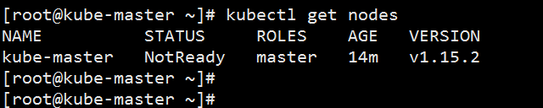
[root@kube-master ~]# kubectl get pods --all-namespaces
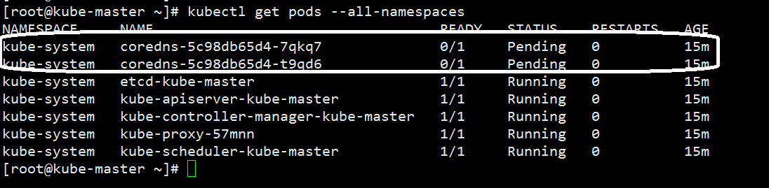

To make the cluster status ready and kube-dns status running, deploy the pod network so that containers of different host communicated each other.

POD network is the overlay network between the worker nodes.
[root@kube-master ~]# export kubever=$(kubectl version | base64 | tr -d '\n')
[root@kube-master ~]# kubectl apply -f "https://cloud.weave.works/k8s/net?k8s-version=$kubever"
serviceaccount "weave-net" created
clusterrole "weave-net" created
clusterrolebinding "weave-net" created
daemonset "weave-net" created
[root@kube-master ~]#
Now, lets chk the DNS pods again,

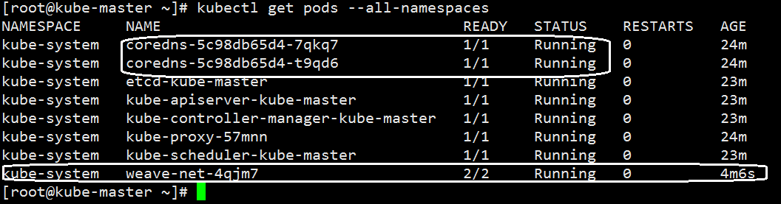
Note: -- This take approx. 2 -5 min sometimes. Please be patient…

Now, that the Kube Master is ready, lets configure the 2 worker nodes for this cluster.

Step 6: Perform the following steps on each worker/Client node

Configure firewall rules on both the Client nodes

Add these firewall ports which is for the worker nodes only on the both nodes as ‘k8s-node1’ and ‘k8s-node2’ respectively
firewall-cmd --permanent --add-port=30000-32767/tcp
firewall-cmd --reload
Output: To chk the firewall config
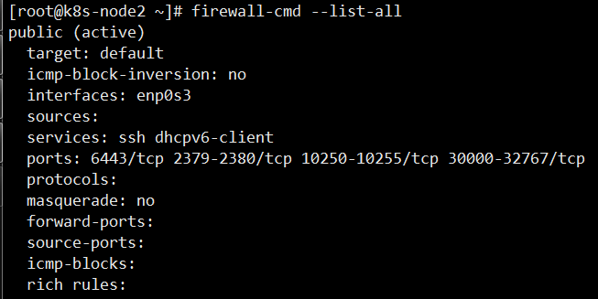

Step 7: Now Join worker/Client nodes to master node

To join worker nodes to Master node, a token is required. Whenever kubernetes master initialized , then in the output we get command and token. Copy that command and run on both nodes.
To get the token on the master
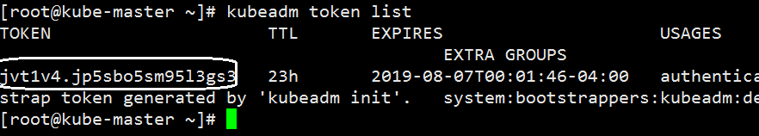
Now, with the join command
[root@k8s-node1 ~]# kubeadm join --token jvt1v4.jp5sbo5sm95l3gs3 192.168.1.101:6443
Here, the Ip address of the master Kube.
Note—you make get an warning
Saying that token is without the certificates and it might be unsafe.
[root@k8s-node1 ~]# kubeadm join --token jvt1v4.jp5sbo5sm95l3gs3 192.168.1.101:6443 --discovery-token-unsafe-skip-ca-verification
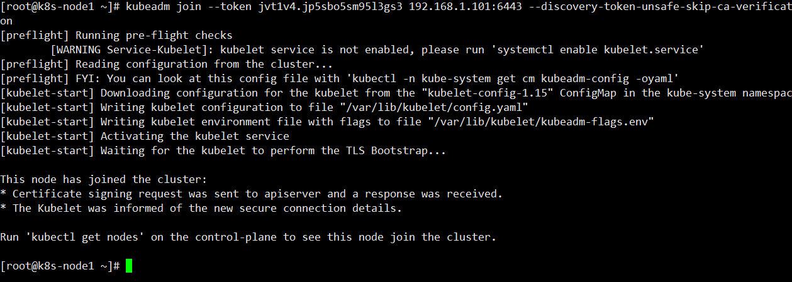
This shows that the node is successfully joined the cluster.
Similarly for Node2.
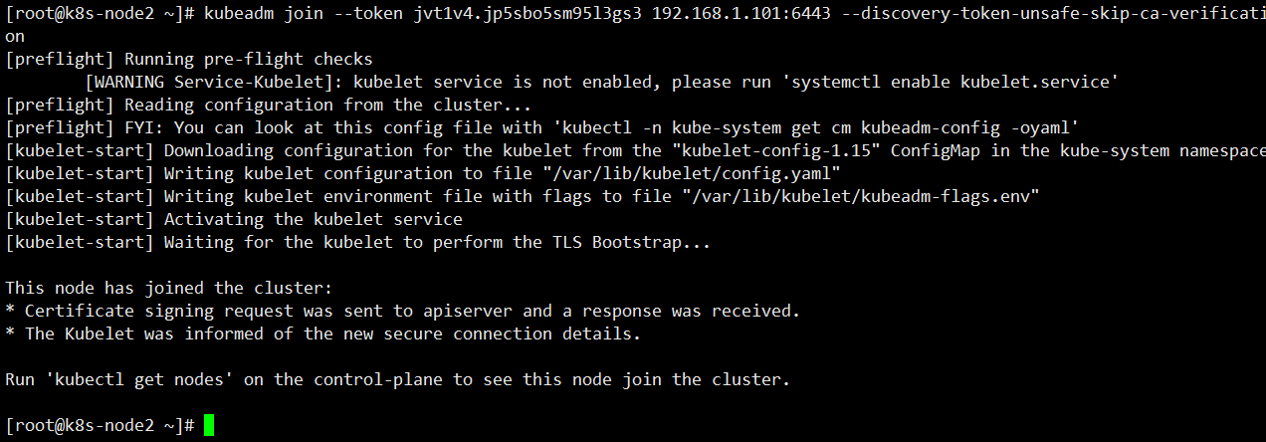

Now verify Nodes status from master node using kubectl command
[root@kube-master ~]# kubectl get nodes
Note: -- It takes around 5 - 9 min for all the nodes to show as “Ready” .
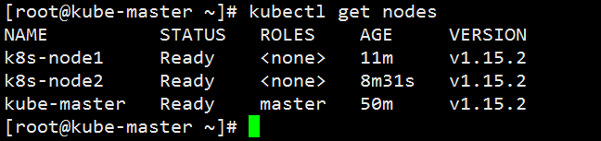
As we can see master and worker nodes are in ready status.
This concludes that kubernetes 1.7 has been installed successfully and also we have successfully joined two worker nodes.
Now we can create pods and services on this Kube Cluster.

